**Restaurant Management**

**Software Requirements Specification**

Version 1.0

Index

1. DOCUMENT HISTORY 3

2. REFERENCES 3

3. DISTRIBUTION LIST AND APPROVALS 3

4. INTRODUCE 3

4.1 Purpose 3

4.2 Target 4

4.3 Scope 4

5. OVERVIEW 5

5.1 Actor 5

5.2 Use Case Diagram 6

*5.2.1* Overall use case diagram 6

*5.2.2* Use case for Guest 7

*5.2.3* Use case for Customer 8

*5.2.4* Use case for Kitchen staff 9

*5.2.5* Use case for Waiter 10

*5.2.6* Use case for restaurant manager 11

*5.2.7* Use case for Restaurant owner 12

5.3 Use Case Descriptions 13

5.4 Pages Flow System 19

6. FUNCTIONAL DESCRIPTION 19

7. NON-FUNCTIONAL AND OTHER REQUIREMENTS 19

7.1 Non-functional requirements: 19

7.2 Development environment requirements 19

# DOCUMENT HISTORY

|  |  |  |
| --- | --- | --- |
| **Date** | **Summary of Changes** | **Version** |
| 01/21/2025 | Software Requirements Specification | 1.0 |
| 02/06/2025 | Software Requirements Specification | 1.1 |
|  |  | 3.0 |

# REFERENCES

|  |  |
| --- | --- |
| **Document Name** | **Description** |
|  |  |
|  |  |
|  |  |
|  |  |

# DISTRIBUTION LIST AND APPROVALS

|  |  |
| --- | --- |
| **Name** | **Title** |
|  |  |
|  |  |
|  |  |
|  |  |
|  |  |

# INTRODUCE

## Purpose

Building a restaurant management website aims to optimize management and operation processes, making tasks such as staff management, table reservations, menus, inventory and revenue more automated and efficient. The website provides utilities such as online table reservations, menu viewing, order status tracking and feedback, thereby improving customer experience and increasing satisfaction. The system also supports departments such as kitchen, service and management to coordinate more effectively, minimize errors and increase productivity.

In addition, the restaurant management website helps centralize and make data transparent, from revenue, employee performance to customer feedback, helping restaurant owners easily access information and make strategic decisions. At the same time, the system also provides detailed reports and analysis to support the development of appropriate business plans. In addition, managing and promoting promotions and events is also easier, contributing to attracting more customers and increasing profits. This website not only helps enhance the professional image of the restaurant but also creates a competitive advantage in the market.

## Target

* **Increase management and operational efficiency**
* Automate management processes (table reservations, food ordering, inventory management, staff,...).
* Minimize human error.
* Support work scheduling, assigning tasks to employees.
* **Enhance customer experience**
* Provide a friendly, easy-to-use interface for customers to reserve tables, order food or make payments.
* Ensure convenience with features like online payment, email/SMS confirmation, and restaurant location display.
* **Improve service quality**
* Monitor customer feedback for timely processing and improvement.
* Manage special events like birthdays, anniversaries to make a good impression.
* **Increase revenue and optimize profits**
* Manage promotions, offers and events to attract more customers.
* Track revenue, profits, and transaction history to analyze business performance.
* Manage loyal customers to maintain long-term relationships and encourage return visits
* **Provide in-depth reporting and analysis**
* Provide detailed reports on revenue, number of customers, food consumption, and effectiveness of each promotion.
* Support management to make quick decisions through visual charts and statistics.

## Scope

* **Restaurant model:** Suitable for single restaurants, medium-sized restaurant chains, or restaurants serving by reservation.
* **Number of customers:** Support handling large number of customers, including walk-in customers and loyal customers.
* **Data Management:** Efficiently manage menus with hundreds of dishes, promotions, and special events. The system also supports storing and processing important information such as reservation history, transaction history, and customer feedback.
* **User:** Designed for managers, restaurant staff, and customers, ensuring an intuitive and easy-to-use interface for everyone.

# OVERVIEW

## Actor

|  |  |
| --- | --- |
| **Actor** | **Describe** |
| Restaurant owner | Store owners can manage all data such as adding, modifying, and deleting information of modules in the system. |
| Restaurant manager | Manage all restaurant operations, including human resources management, menus, sales reports, and employee delegation. |
| Service staff | Waiters take orders, pay, and assist customers at the table. |
| Kitchen staff | The kitchen staff is responsible for communicating the order to the chef, and reporting the status of the ordered dishes. |
| Customer | Customers use restaurant services such as reservations, ordering, payment, reviews, and promotional notifications. They can register for an account to manage their transaction history and personalize their experience. |

## Use Case Diagram

### Overall use case diagram

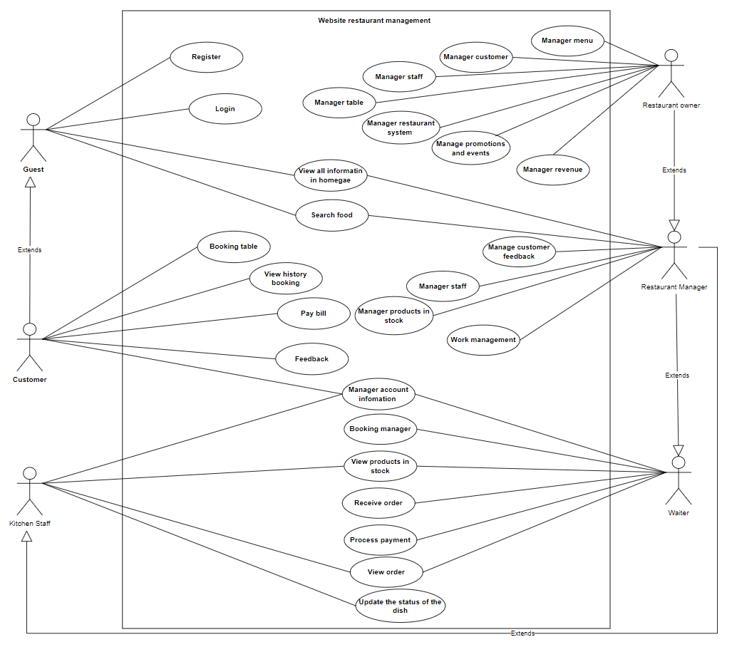

### Use case for Guest

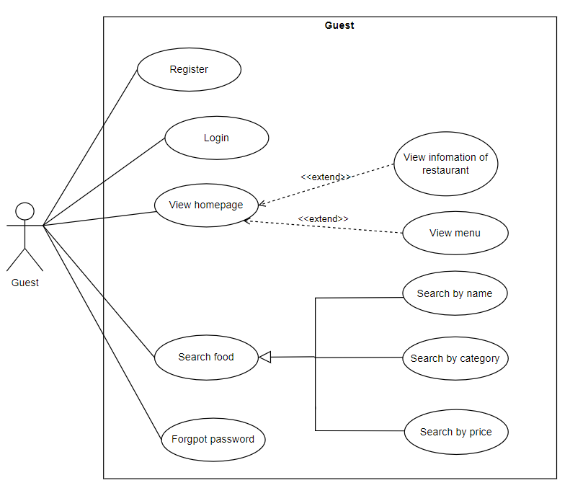

### Use case for Customer

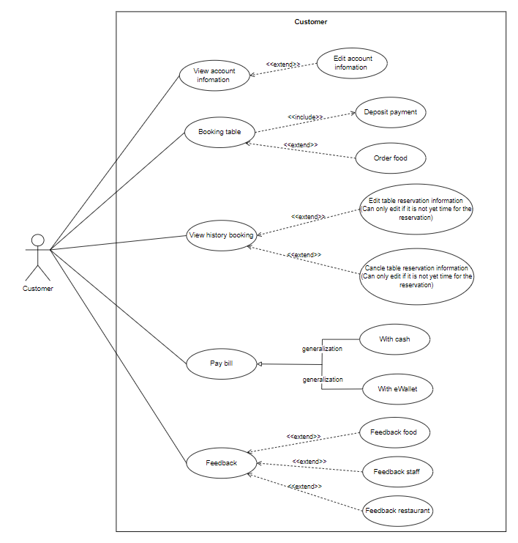

### Use case for Kitchen staff

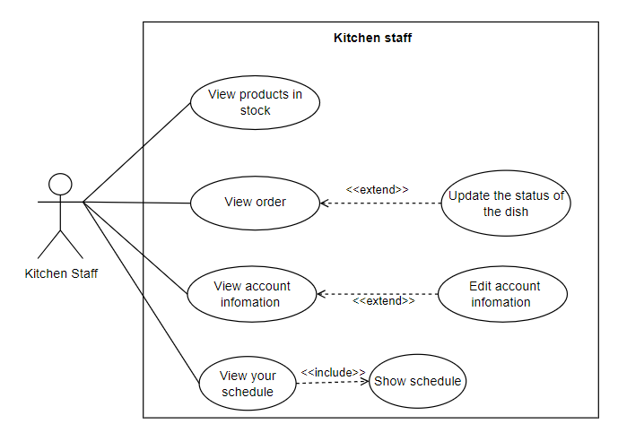

### Use case for Waiter

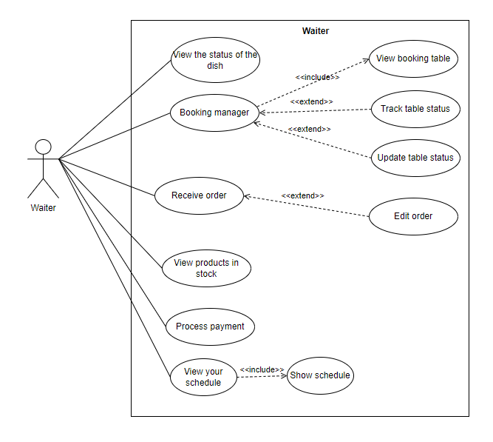

### Use case for restaurant manager

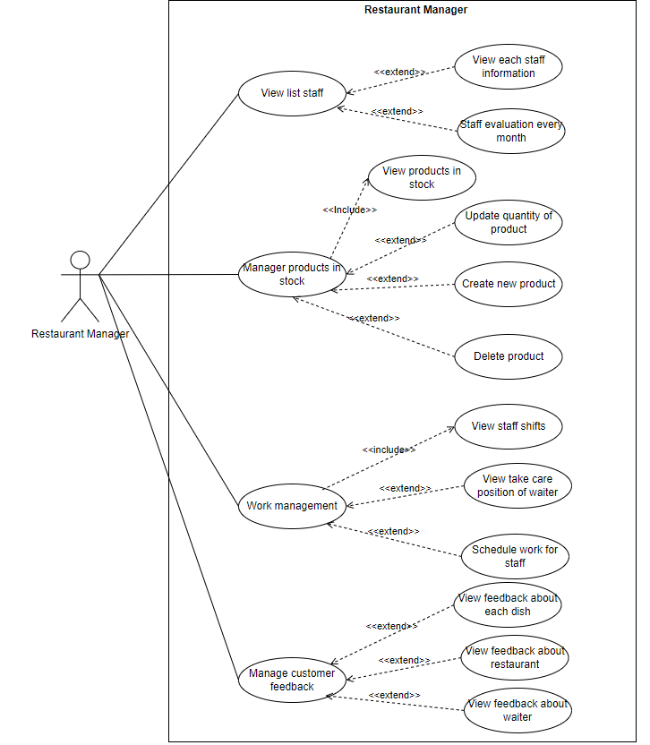

### Use case for Restaurant owner

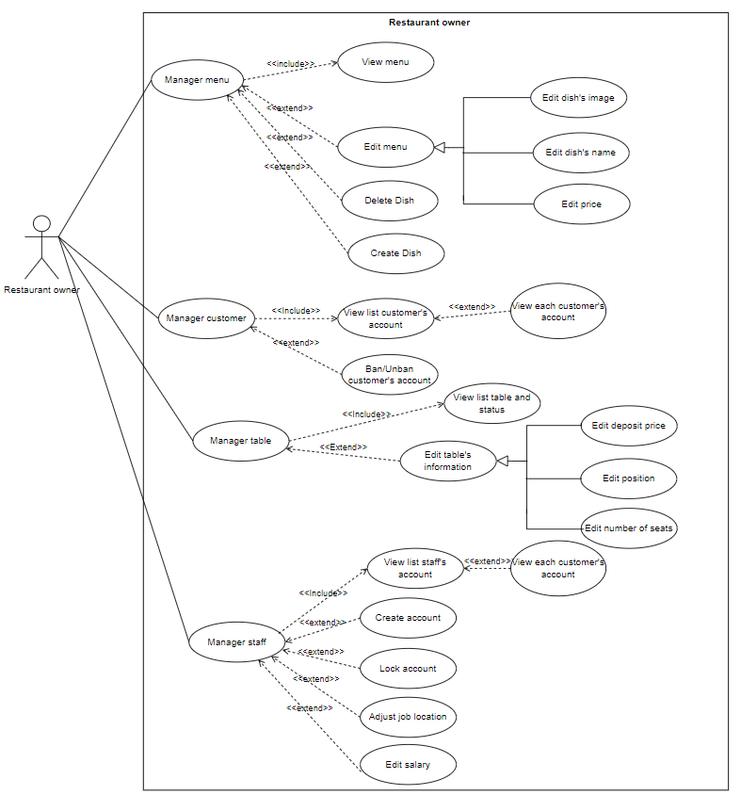

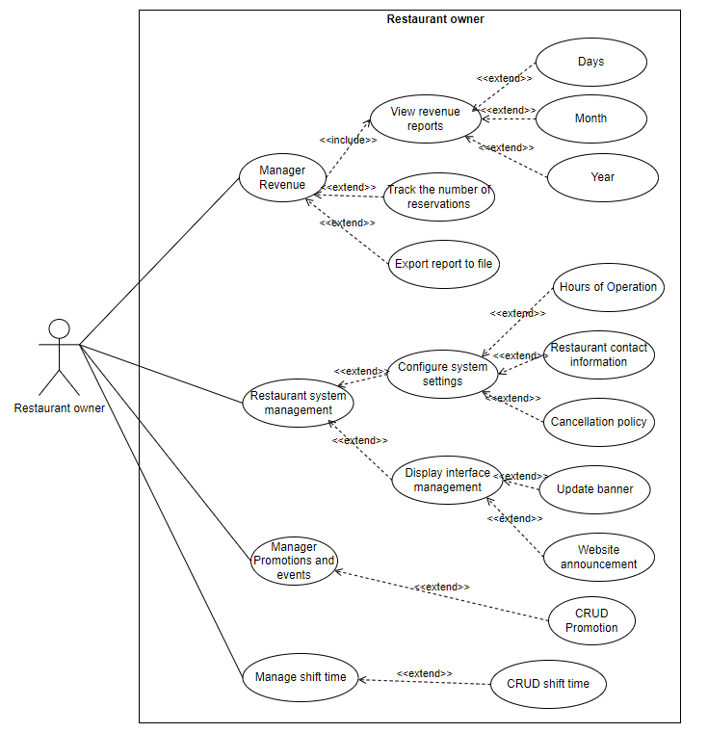

## Use Case Descriptions

|  |  |  |  |
| --- | --- | --- | --- |
| **ID** | **Use Case** | **Actor** | **Use Case Description** |
| UC-1 | Login | - Restaurant owner  - Restaurant manager  - Waiter  - Kitchen staff  - Customer | Allows a user to log into the system using their username and password |
| UC-2 | Login by google | Customer | Enables a user to log in using their Google account. |
| UC-3 | Register an account | Guest | Allows a new user to create an account in the system. |
| UC-4 | Logout | - Restaurant owner  - Restaurant manager  - Waiter  - Kitchen staff  - Customer | Enables a logged-in user to log out of the system |
| UC-5 | Change password | - Restaurant owner  - Restaurant manager  - Waiter  - Kitchen staff  - Customer | Allows a user to change their current password to a new one. |
| UC-6 | Reset password | - Restaurant owner  - Restaurant manager  - Waiter  - Kitchen staff  - Customer | Enables a user to reset their password in case they forget it. |
| UC-7 | View account information | - Restaurant manager  - Waiter  - Kitchen staff  - Customer | Allows a user to view the details of their account. |
| UC-8 | Update account information | - Restaurant manager  - Waiter  - Kitchen staff  - Customer | Enables a user to update their account details, such as name, email, or phone number. |
| UC-9 | View menu | - Restaurant manager  - Waiter  - Kitchen staff  - Customer  Guest | Allows a user to view the list of dishes available in the menu. |
| UC-10 | Search dish in menu | - Restaurant owner  - Restaurant manager  - Waiter  - Kitchen staff  - Customer  Guest | Enables a user to search for specific dishes within the menu using keywords or filters. |
| UC-11 | Create new dish in menu | - Restaurant owner | Allows a restaurant owner to add a new dish to the menu. |
| UC-12 | Update dish in menu | - Restaurant owner | Enables a restaurant owner to modify the details of an existing dish in the menu, such as name, price, image, or description |
| UC-13 | Delete dish in menu | - Restaurant owner | Allows a restaurant owner to remove a dish from the menu. |
| UC-14 | View staff information | - Restaurant owner  - Restaurant manager | Allows an authorized user to view details of staff members, including their roles and job status. |
| UC-15 | Create staff account | - Restaurant owner | Enables a restaurant owner to create new accounts for staff members |
| UC-16 | Lock staff account | - Restaurant owner | Allows a restaurant owner to temporarily disable a staff member's account. |
| UC-17 | Update salary of staff | - Restaurant owner | Allows a restaurant owner to modify the salary details of a staff member. |
| UC-18 | View customer's information | - Restaurant owner | Allows a restaurant owner to view the details of a specific customer, such as personal information, order history, and account status. |
| UC-19 | Ban/Unban customer's account | - Restaurant owner | Enables a restaurant owner to temporarily suspend (ban) or restore (unban) a customer's account based on certain conditions or violations of terms. |
| UC-20 | View list table and status | - Restaurant owner  - Restaurant manager  - Customer  - Waiter | Allows a restaurant owner to view the list of all tables and their current statuses (eg, available, occupied, reserved) |
| UC-21 | Update table's information | - Restaurant owner | Enables a restaurant owner to modify the details of a table, such as its position, seating capacity, deposit price or status. |
| UC-22 | View promotions and events | - Restaurant owner | Allows a restaurant owner to view the list of ongoing and upcoming promotions and events in the system |
| UC-23 | Create promotion and event | - Restaurant owner | Enables a restaurant owner to create new promotions or events, including setting the details such as dates, offers, and conditions |
| UC-24 | Update promotion and event | - Restaurant owner | Allows a restaurant owner to modify the details of an existing promotion or event, such as changing the dates, terms, or discounts. |
| UC-25 | Delete promotion and event | - Restaurant owner | Enables a restaurant owner to remove a promotion or event from the system. |
| UC-26 | View revenue report | - Restaurant owner | Allows a restaurant owner to view detailed revenue reports, including daily, weekly, or monthly income from orders and reservations. |
| UC-27 | Track the number of reservations | - Restaurant owner | Enables a restaurant owner to monitor and track the total number of made reservations within a specific time period. |
| UC-28 | Configure system settings | - Restaurant owner | Allows a restaurant owner to customize system settings, including:   * **Hours of Operation** : Define the opening and closing hours for the restaurant. * **Restaurant Contact Information** : Update details such as phone number, email address, and physical location.   **Cancellation Policy** : Set rules and conditions for reservation cancellations, including deadlines and fees. |
| UC-29 | Update banner | - Restaurant owner | * Allows a restaurant owner to change or update the banner displayed on the website, such as uploading new images or promotional content. |
| UC-30 | Staff evaluation every month | - Restaurant manager | Allows a Restaurant manager to assess staff performance on a monthly basis, including tracking key metrics like punctuality, customer feedback, and task completion. |
| UC-31 | Create take care of waiter’s position | - Restaurant owner  - Restaurant manager | Enables an authorized user to view the assigned positions or areas that a waiter is responsible for, such as specific tables or sections. |
| UC-32 | View take care of waiter's position | - Restaurant owner  - Restaurant manager | Enables an authorized user to view the assigned positions or areas that a waiter is responsible for, such as specific tables or sections. |
| UC-33 | Schedule work for staff | - Restaurant owner  - Restaurant manager | Allows an authorized user to create and assign work schedules for staff members, specifying their roles and shift times. |
| UC-34 | View feedback | - Restaurant owner  - Restaurant manager | Allows an authorized user to view customer feedback, including:   * **Dish** : Comments and ratings on specific dishes. * **Staff** : Feedback related to staff performance or behavior.   **Restaurant** : General feedback on the overall dining experience, ambiance, or service quality. |
| UC-35 | View booking table | - Restaurant owner  - Restaurant manager  - Waiter | * Allows an authorized user to view the list of table reservations, including details such as customer name, reservation time, and table number |
| UC-36 | Update table status | - Restaurant owner  - Restaurant manager  - Customer  - Waiter | Enables an authorized user to change the status of a table (eg, available, occupied, reserved, or out of service) |
| UC-37 | Receiver order | - Restaurant manager  - Customer  - Waiter | Allows an authorized user to take and confirm customer orders for food and beverages. |
| UC-38 | View the status of the dish order | - Restaurant owner  - Restaurant manager  - Customer  - Waiter | Enables an authorized user to check the preparation and delivery status of dishes ordered by customers. |
| UC-39 | Process payment | - Restaurant manager  - Customer  - Waiter | Allows an authorized user to handle customer payments, including generating bills and recording transactions. |
| UC-40 | View work schedule | - Customer  - Waiter | Allows an authorized user to view their own work schedule, including assigned shifts and tasks. |
| UC-41 | Update the status of the dish | - Kitchen staff | Allows an authorized user to modify the current status of a dish order, such as "Pending," "In Preparation," "Ready to Serve," or "Served." |
| UC-42 | Booking table | - Customer | Allows a customer to make a reservation for a table at the restaurant by selecting a date, time, and table preference. |
| UC-43 | Order dishes online | - Customer | Allows a customer to place an order for food and beverages through the restaurant's online platform, select items from the menu and complete the order for delivery or pick-up. |
| UC-45 | View booking history | - Customer | Allows a customer to view their past table reservations, including the date, time, and table details |
| UC-46 | Update booking | - Customer | Allows a customer to modify their existing table reservation, such as changing the reservation time, number of guests, or special requests. |
| UC-47 | Cancel booking | - Customer | Enables a customer to cancel their existing table reservation if plans change or they no longer wish to dine at the restaurant |
| UC-48 | Feedback | - Customer | Allows a customer to provide feedback on their dining experience, including:   * **Dish** : Feedback on the quality, taste, and presentation of the dishes. * **Waiter** : Comments on the service and behavior of the waiter. |

## Pages Flow System

# FUNCTIONAL DESCRIPTION

# NON-FUNCTIONAL AND OTHER REQUIREMENTS

## Non-functional requirements:

* Interface: Easy to use, clear, friendly
* Performance: Processing speed, fast and accurate results.
* Security: Has a clear authorization system, uses a highly secure database.
* Flexible: Easy installation, multi-platform support, use on many different devices
* Multilingual: No multilingual support

## Development environment requirements